Q 5: addition of two no flow chart:

Addition of two number process start and out put two answer of two different addition

By liner flow chart

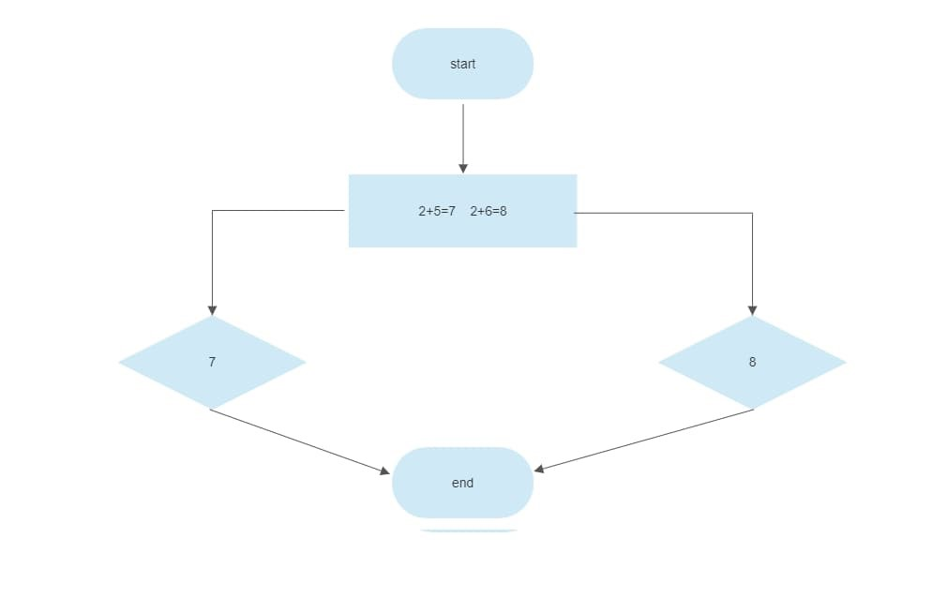

By branching flow chart:

